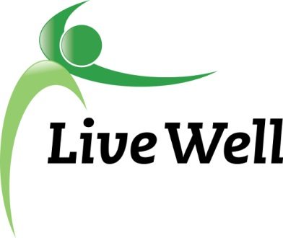
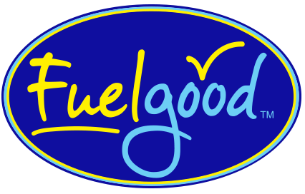

Fuel Good+Pantries = Healthy Food for All
You have been nominated to become a Fuel Good+Pantry partner!
Sponsored by Livewell Lawrence and the Healthy Food for All Workgroup Fuel Good pantries make the healthy choice the easy choice.
Why?
- Healthy food is directly related to improved health outcomes.
- Families express that they want healthy food choices.
- Food pantries and feeding sites have a unique opportunity to contribute to the health of underserved populations.
- Partners contribute to improving local health, local economy, and local sustainability.

What are the benefits?
- Receive support and tips for meeting increased client demands for healthy options.
- Promotional marketing and nutritional education materials for your location.
- Assistance maximizing space and food storage options so your pantry can provide healthy food.
- Guidelines to help suggest types of foods donated.
- Time-saving tips and resources to provide additional programming efforts.
- Community recognition.
- Participation may contribute to future grant funding opportunities.

What are the intended goals, objectives, and outcomes for this program?
Mission
Contribute to increased access and consumption of healthy food, nutrition education, and health resources available to food assistance program clientele in Douglas County.

Program Goals
1. Incorporation of fuel good standards as a food purchasing and collecting practice.
2. Assist more food-insecure people by increasing SNAP enrollment opportunities.
3. Provide increased education about healthy foods and activities, including benefits, choices, production, and preparation.

Objectives
The objectives of the Fuel Good+Pantries program include participating food pantries and feeding sites to:
1. Demonstrate a large percentage of foods purchased or collected that meet Fuel Good standards.
2. Develop an advocacy program that supports the attainment of Fuel Good standards.
3. Provide SNAP enrollment training for employees and volunteers.
4. Provide educational training, materials, and events about healthy foods, activities, gardening, and cooking for patrons, staff and volunteers.

Outcomes
1. Increased number of food pantries and feeding sites offering Fuel good standards food, nutrition education, and health resources.
2. Make healthier food choices available (at least 70% of available food meets Fuel Good standards.
3. Reduce food insecurity by increasing the number of clients enrolled in food assistance programs.
4. Support clients to adopt healthy behaviors with education and supportive programming.

For more information, Please contact the Healthy Food for All Work Group:
Email: info@livewelllawrence.org

